*Florida International University*

*School of Computing and Information Sciences*

CIS 4911 - Senior Capstone Project

Software Engineering Focus

Feature Document

User Story # 1065

**Team Member:**

Michael Martinez

**Product Owner(s)**:

Mohsen Taheri

**Mentor(s)**:

Mohsen Taheri

**Instructor**:

Mohsen Taheri

**User Story** Manage and View Admin Panel

**Description**

As a PI, I would like to view the list of all registered users so that i can manage them and delete whatever or whoever I want and change their projects. Also I would be able to list them based on some filters and send them a message.

**Acceptance Criteria**

1. I want to see the list of the users and **his/her project or projects** and when i click on the name of each user , it should show me the **complete** information of him/her which he has already inserted.
2. Must be able to remove users **from VIP website completely.**
3. Must be able to change user’s project using a drop-down menu easily.
4. Must be able to list them based on usertype, their project assignment status and the name of project.
5. Changes must be reflected in the database
6. PI must be able to send message to students or some students
7. PI must be able to see the list of unconfirmed users too so that he would be able to confirm or reject them.
8. PI must be able to change the usertype of a user by a dropdown menu

**Use Case**

1. Participating Actors: User  
     
   Entry Condition: must be a PI/Co-PI  
   Events Flow:
2. Click on wrench to open admin panel.
3. Can see a list of users based on filter.
4. Can filter users based on usertype, user’s rank, unconfirmed email, gmail login, mentor, project, and multiple projects.
5. Can see detailed information of any user.
6. Can remove users from VIP website completely.
7. Can change user’s project.
8. Can change user’s usertype.
9. Can send messages to a user or multiple users.
10. Can confirm or reject unconfirmed users.

**Use Case Diagram**

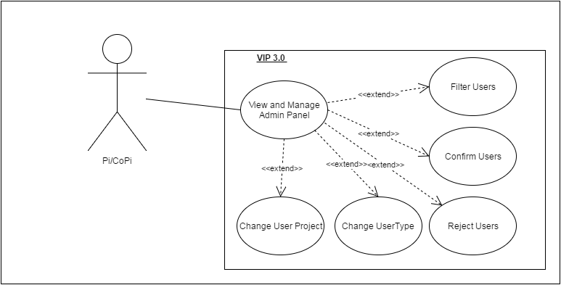

**Sequence Diagram**

1. **Confirm User Sequence Diagram**

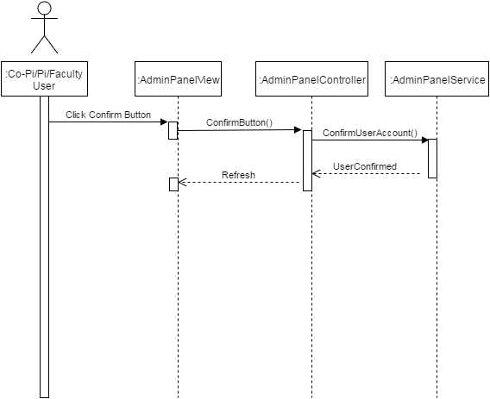

**B. Reject User Sequence Diagram**

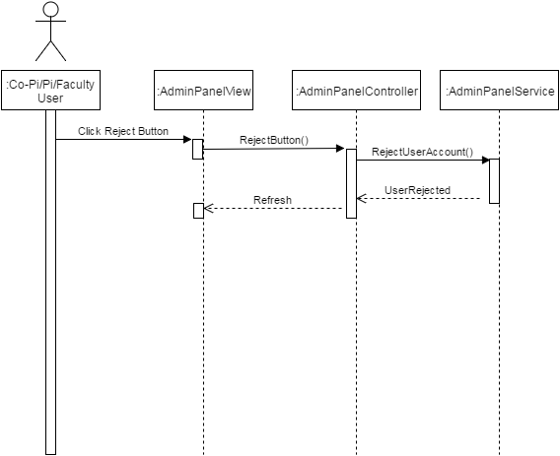

**C. Delete User Sequence Diagram**

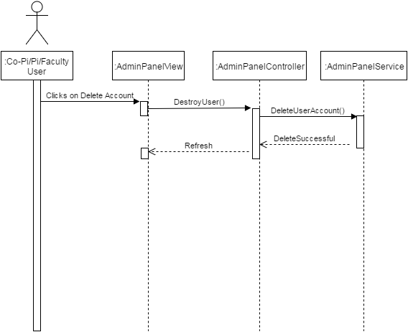

**D. Change UserType Sequence Diagram**

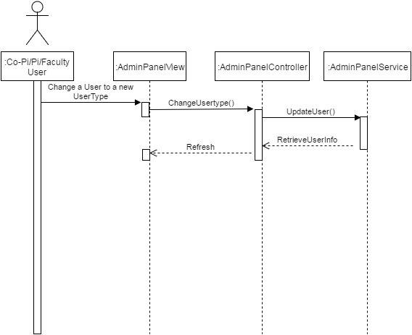

**E. Filter User Sequence Diagram**

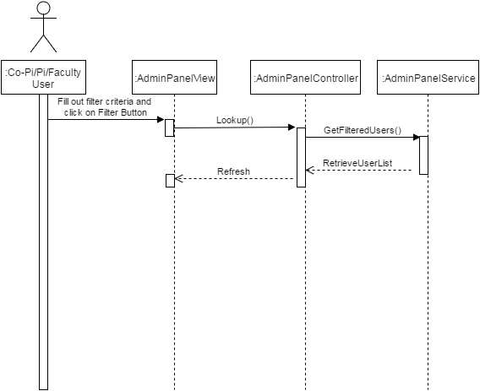

**Minimal Class Diagram**

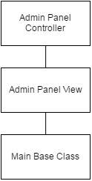

**Unit Test**

**Test Case 1 Sunny Day (PASS)**

* **Purpose**

To test that change UserType works

* **Precondition**

User account selected on drop-down

* **Input**

Change usertype from student to Co-PI/PI

* **Expected Result**

Usertype changed to Co-PI/PI

* **Actual Result**

As Expected Result.

**Test Case 2 Rainy Day (FAIL)**

* **Purpose**

To test that reject unconfirmed user doesn’t delete account

* **Precondition**

Select User account on drop-down

* **Input**

Click on Reject Button

* **Expected Result**

Account rejected but account not deleted.

* **Actual Result**

Account gets deleted.

**Visual User Guide**

1. **Click on Wrench Icon.**

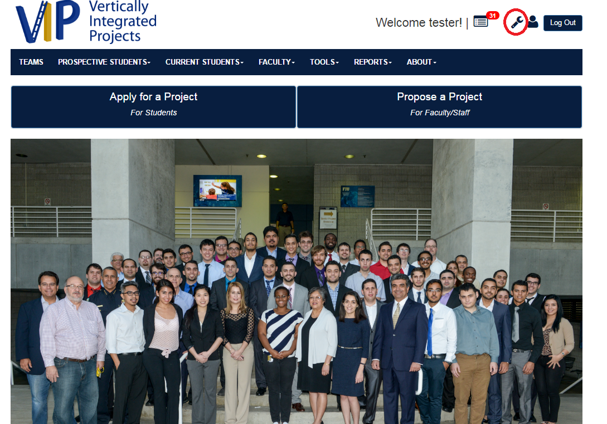

**2. Input desired filters for users and then click on lookup.**

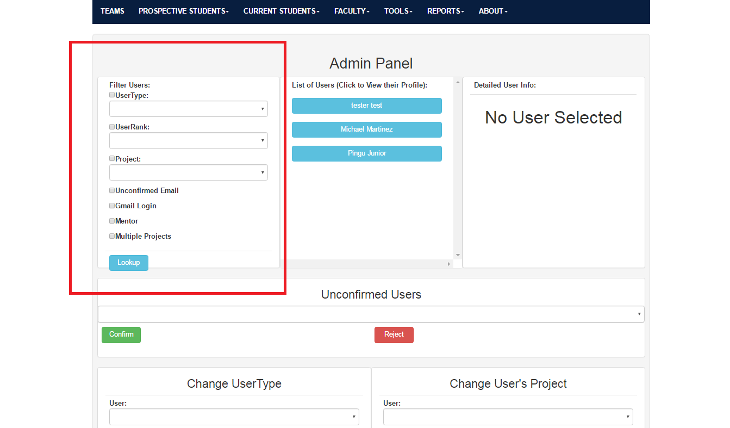

**3. Click on a user to see their information**

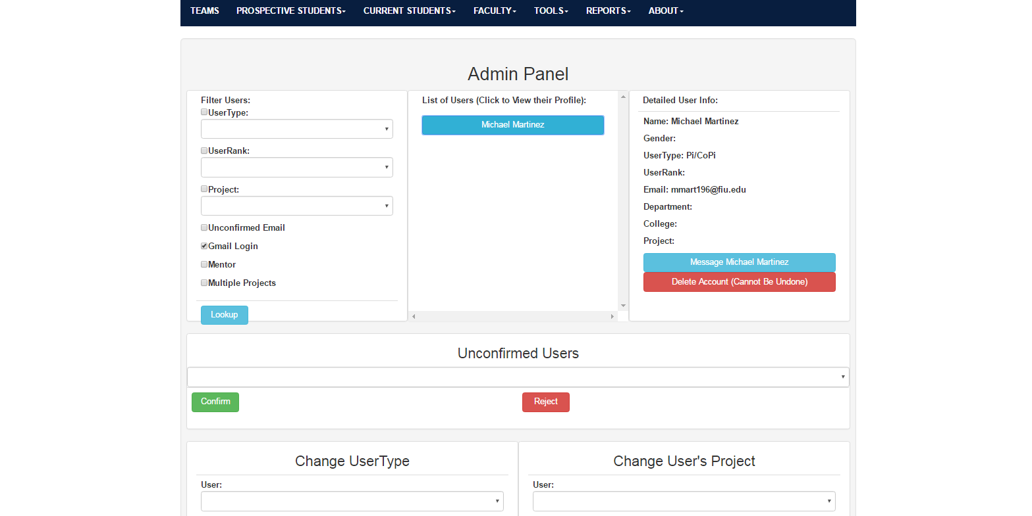

**4. Decide to message or delete the account. Then, scroll down and notice that the drop downs are affected by the filters that you made. You can confirm or reject users, You can change UserType of a user account or change a user’s project.**

